EXPERIMENT – 1

ARDUINO UNO-BASED SMART HOME SAFETY AND OCCUPANCY MONITORING SYSTEM USING GAS, PIR AND ULTRASONIC SENSORS

➔ PROGRAM:
#define GAS_PIN A0
#define PIR_PIN 2
#define TRIG_PIN 8
#define ECHO_PIN 9
#define BUZZER 10
#define LED 11

void setup()
{
Serial.begin(9600);

pinMode(PIR_PIN, INPUT);
pinMode(TRIG_PIN, OUTPUT);
pinMode(ECHO_PIN, INPUT);
pinMode(BUZZER, OUTPUT);
pinMode(LED, OUTPUT);
}

void loop()
{
int gas = analogRead(GAS_PIN);
int motion = digitalRead(PIR_PIN);

digitalWrite(TRIG_PIN, LOW);
delayMicroseconds(2);

digitalWrite(TRIG_PIN, HIGH);
delayMicroseconds(10);

digitalWrite(TRIG_PIN, LOW);

long duration = pulseIn(ECHO_PIN, HIGH);
float distance = duration * 0.0343 / 2;

if (gas > 500)
digitalWrite(BUZZER, HIGH);
else
digitalWrite(BUZZER, LOW);

digitalWrite(LED, motion);

Serial.print("Gas Level: ");
Serial.println(gas);

Serial.print("Motion: ");

if (motion)
Serial.println("DETECTED");
else
Serial.println("NOT DETECTED");

Serial.print("Distance: ");
Serial.print(distance, 1);
Serial.println(" cm");

if (gas > 500)
Serial.println("GAS ALERT!");
else if (motion)
Serial.println("OCCUPANCY DETECTED");
else
Serial.println("SYSTEM SAFE");

Serial.println("--------------------");

delay(1000);
}

Output
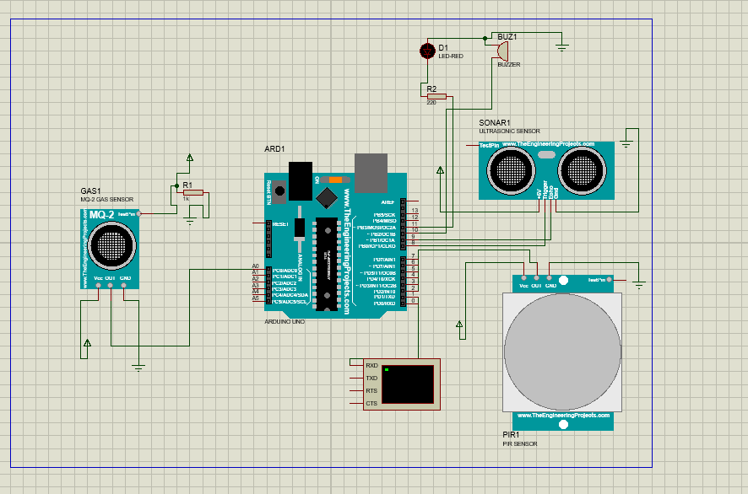
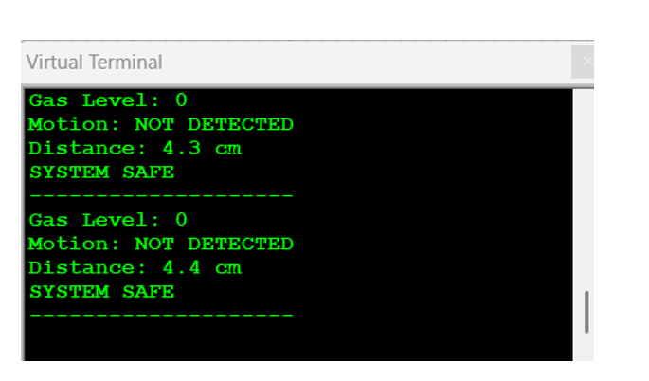
Reflection
Through this experiment, I learned how to acquire temperature data using an ADC and control fan speed using PWM generated by timer interrupts. I understood how temperature readings can be used to adjust the fan speed automatically in an industrial HVAC system. This experiment helped me gain practical knowledge of ADC, timers, interrupts, and PWM control, which are important for efficient temperature regulation and energy saving.

